Article 18 — The Remediation Layer

Michal Doroszewski

The Janitor With No Map
You’re in a massive office building. The fire alarm goes off. Smoke drifts through the hallway. A janitor grabs a fire extinguisher and runs toward the source. But the hallway is blocked. He turns left. The door is locked. He turns right. The sign says “Under Construction.” He checks the building map. It’s outdated. He radios for help. The signal drops. He tries again. The response says, “Remediation in progress.”

He reaches the room. The fire is gone. The sprinklers triggered. The server racks are soaked. The power is out. The remediation happened — but not where it was needed, not when it was needed, and not with the right tools.

The janitor isn’t untrained. He’s misdirected. He’s unsupported. He’s operating in a system that cannot see clearly, cannot respond coherently, and cannot remediate predictably.

That is the Remediation Problem — not the “bad playbook” kind, but the architectural kind. The kind that appears when cloud systems attempt to remediate identity, risk, and access issues using partial truth, delayed signals, and inconsistent logic. The kind that turns a helpful janitor into a blindfolded firefighter.

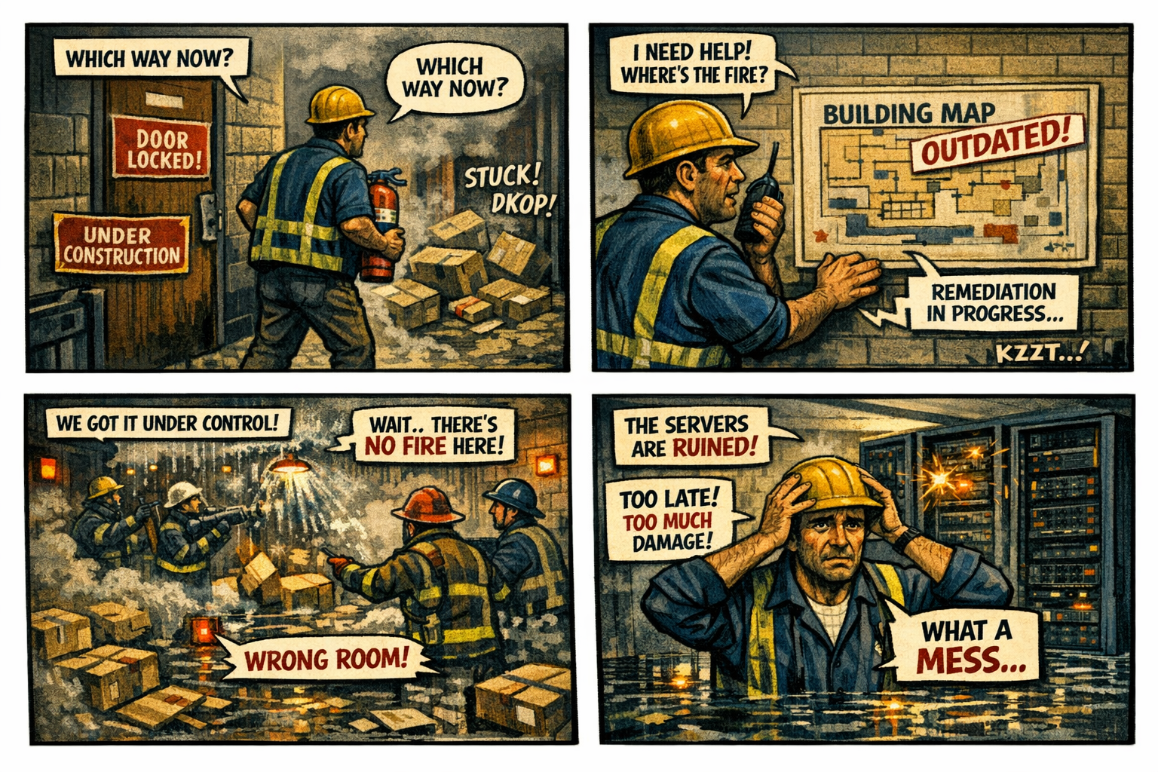

Remediation Is the Eighth Layer of Modernization
Visibility shows what is happening. Continuity stabilizes identity across transitions. Control determines what the system is allowed to do. Signals carry the truth. Evaluation interprets the truth. Decision enforces the truth. Automation scales the enforcement. But remediation repairs the damage.

Remediation is the recovery engine. It is the force that resets sessions, revokes tokens, re‑evaluates posture, re‑establishes trust, and restores access.

When remediation is grounded in truth, it restores stability. When remediation is grounded in uncertainty, it amplifies instability.

A system that cannot remediate safely cannot recover. A system that cannot recover cannot modernize.

Why GCC‑Moderate Breaks Remediation
The FedRAMP Moderate boundary was built for static recovery, not dynamic remediation. It filters the signals. It delays the timing. It distorts the context. It mislabels the location. It fragments the truth.

Remediation engines receive partial input:
They see posture but not session context. They see location but not risk. They see the device but not the refresh signal. They see the user but not the compliance state.

Remediation doesn’t wait. It doesn’t ask for confirmation. It doesn’t pause for clarity.

It acts. It resets. It revokes. It denies. It loops.

The system is not punishing the user. It is remediating the uncertainty.

Headquarters and Field Offices Experience Remediation Differently
At headquarters, remediation behaves predictably. Signals arrive intact. Context is preserved. Recovery is clean.

In field offices, remediation behaves erratically. Signals arrive late. Context is distorted. Recovery misfires.

The same user, same device, same request — different remediation outcome. The architecture creates two realities, and remediation enforces both.

Why Remediation Failures Are Misdiagnosed
When remediation collapses, every team sees a different symptom.

Security sees revoked tokens. Identity sees session resets. Network sees re‑authentication loops. Operations sees region‑wide instability. Users see repeated denials.

Everyone is correct. Everyone is wrong.

The failure is architectural. Remediation is reacting to the uncertainty created by the boundary.

Modernization Stalls Without Remediation
Without reliable remediation:

- sessions reset unpredictably
- tokens revoke unnecessarily
- posture re‑evaluates inconsistently
- access loops reappear
- trust resets cascade
- users lose confidence
- teams chase phantom triggers

This is not a playbook problem. It is architectural instability in recovery.

The Root of the Remediation Problem
The remediation problem is not caused by bad scripts, misconfigured triggers, incorrect thresholds, or user error. It is caused by an architecture that cannot reliably deliver the truth required for dynamic recovery.

The boundary filters the truth. The WAN delays the truth. The inspection layers distort the truth. The region model mislabels the truth. The identity platform receives partial truth.

Remediation cannot function on partial truth. Remediation cannot recover inside a fog.

The Only Way Forward
Remediation integrity must be restored.

The boundary must allow identity‑critical signals. Timing must be preserved. Region awareness must be accurate. Device posture must be current. Risk evaluation must be complete. Session context must be intact. Policy logic must receive the full truth. Remediation must operate on stable, consistent inputs.

Only then can recovery be predictable. Only then can trust be restored. Only then can modernization move forward without looping damage.

Disclaimer
Not all agencies will experience the issues described in this article. These behaviors occur primarily in architectures where cloud identity, Conditional Access, and real‑time policy evaluation depend on signals that traverse GCC‑Moderate boundaries, WAN inspection layers, or region‑variable paths. Agencies that rely on direct Active Directory authentication, maintain on‑premises identity controllers, or operate with short, stable network paths may see different outcomes. These observations reflect common patterns in GCC‑Moderate cloud environments, not universal conditions.

About the Author
Michal Doroszewski is a technology strategist focused on cloud architecture, identity platforms, and federal modernization. He writes about the structural and architectural forces that shape government IT, translating complex technical constraints into clear, accessible narratives for leaders and practitioners.

